# Executive Summary

Managing a personal library can be a tedious task, especially with a community that continues to rapidly expand as each academic year passes by. The Developers Society (DevSoc) of Nottingham Trent University (NTU) has an ever-growing collection of literature stored in a cabinet within their office. The mini library is open to the general member base to borrow, read and return which has given way to a rather challenging problem to manage. As the community size has now grown well beyond 800 members it has become increasingly difficult to try and keep track of who has taken a book and not returned it.

The solution to this would be a mobile app that’s easily accessible that allows users to scan a book via an NFC sticker before registering themselves as the current borrower. This information would then get stored on a cloud database that’s available for the current society’s committee to access. This system creates a more formal borrow and return process for the society that allows them to keep track of a book’s borrower history. Moreover, users will be able to check the status of a book before making a trip to go collect it. Additional features of the app may include short and detailed summaries of each book to help assist a user in picking the right book from the available resources. Subsequently, an expansion of the app can include other facets of the society’s operations that could be digitised (e.g. taking event attendance, logging event interest).

# Usability, Requirements and Guidelines

# Constraints

# Proposed Idea and Impact

# Application Features

# Evaluation of Paper Prototype

# Appendix

## Persona 1 – Alice

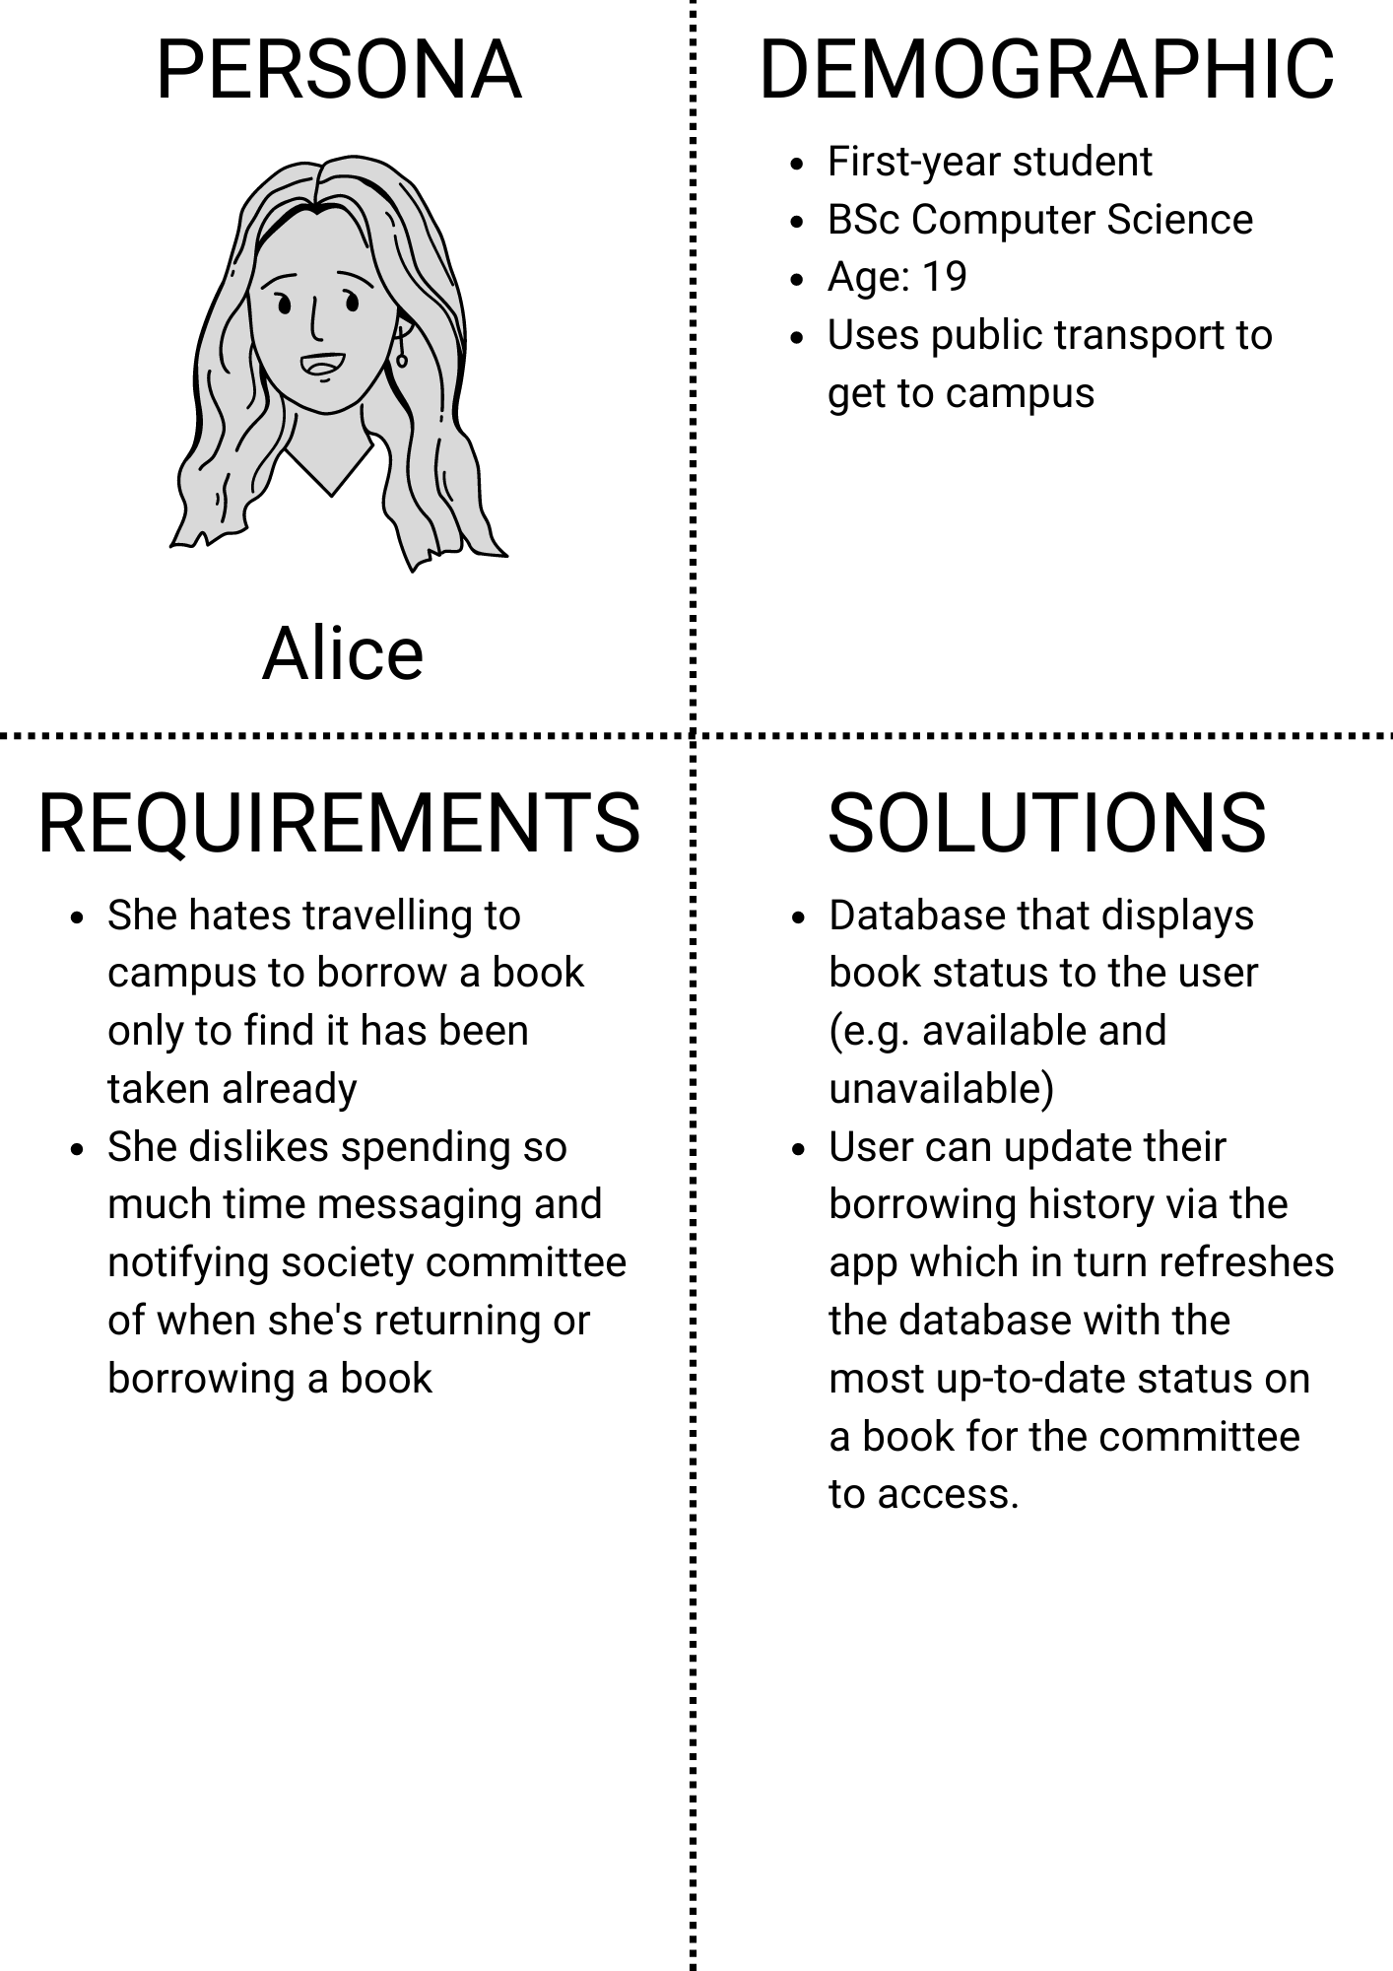

## Persona 2 – Carl

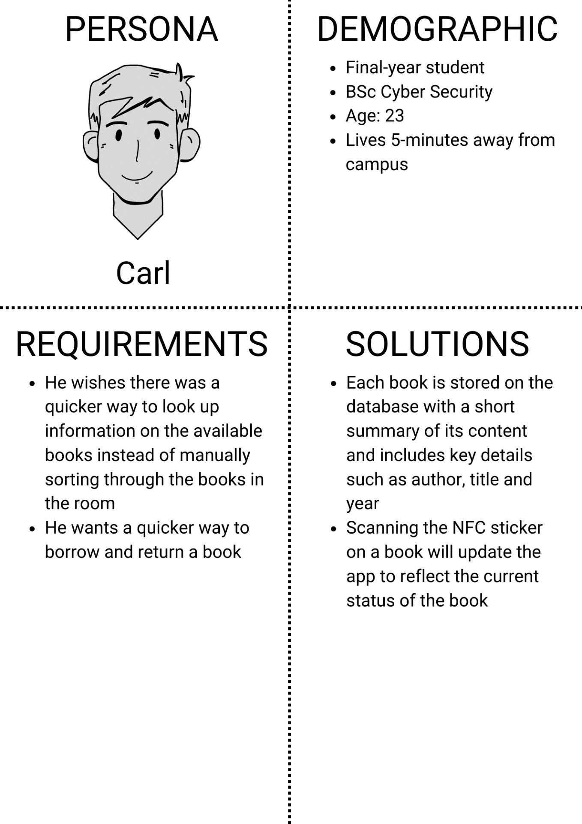

## Persona 3 – Beth

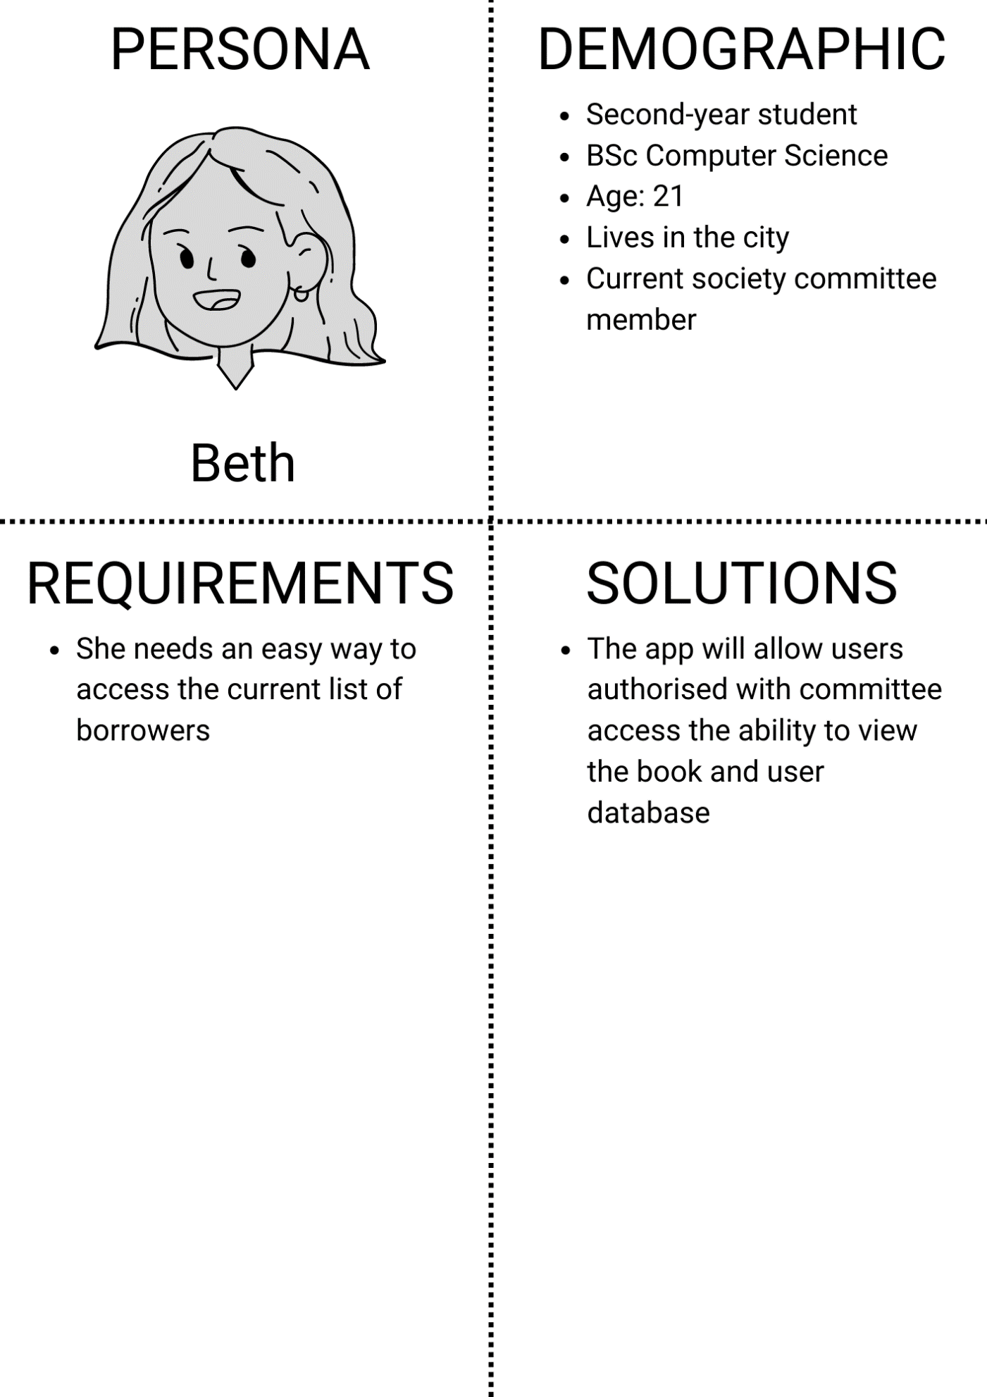

## Paper Prototype (Before user testing)

## Paper Prototype (After user testing)